**A REAL-TIME MULTILINGUAL**

**VIRTUAL VOICE ASSISTANT**

**FOR LEARNERS**

**A Project Report**

Submitted in partial fulfilment of the

Requirements for the award of the Degree of

**MASTER OF SCIENCE (INFORMATION TECHNOLOGY)**

**By**

Janhavi Vijay Kharkar

**-------------------------**

**Under the esteemed guidance of**

**Dr. Sunitha Joshi**

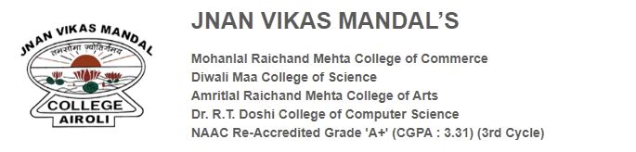

**DEPARTMENT OF INFORMATION TECHNOLOGY**

**JNAN VIKAS MANDAL’S MEHTA DEGREE COLLEGE**

***(Affiliated to University of Mumbai)***

**AIROLI, NAVI MUMBAI-400708**

**MAHARASHTRA**

**2023-2024**

**PROFORMA FOR THE APPROVAL PROJECT PROPOSAL**

***(Note: All entries of the proforma of approval should be filled up with appropriate and complete information. Incomplete proforma of approval in any respect will be***

***summarily rejected.)***

PNR No**.: ……………………**  Roll no**: ___________**

1. Name of the Student

__________________________________________________________________

2. Title of the Project

__ _______________________________________________________________

3. Name of the Guide

__________________________________________________________________

4. Teaching experience of the Guide ____________________________________

5. Is this your first submission? Yes No

Signature of the Student Signature of the Guide

Date: ………………… Date: …………………

Signature of the Coordinator/HOD

Date: …………………

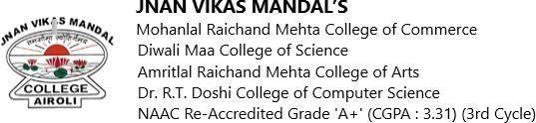

**DEPARTMENT OF INFORMATION TECHNOLOGY**

**CERTIFICATE**

This is to certify that **Janhavi Vijay Kharkar** bearing seat no -------------------- has done the project work **A Real-Time Multilingual Virtual Voice Assistant for Learners** of Semester III Practical Examination during the Academic Year 2024-25 under the guidance of **Dr. Sunitha Joshi** being the partial requirement for the fulfilment of the curriculum of Degree in Master of Science in Information Technology under University of Mumbai.

Place: Airoli Date:

Sign of Subject in- Charge Sign of External Examiner

Sign of Coordinator

**ABSTRACT**

The objective of this project is to develop a real-time multilingual virtual voice assistant designed to enhance the learning experience for users. This system is capable of understanding user queries in Hindi, Marathi, and English and responding in their preferred language. By integrating advanced natural language processing (NLP) and speech recognition technologies, the assistant ensures seamless and accurate multilingual communication, fostering inclusivity and accessibility in diverse educational settings.

A unique feature of the system is its camera-based text scanning capability, allowing users to capture printed text from books, documents, or other materials. The scanned text is processed and converted into speech in the user’s chosen language using state-of-the-art text-to-speech technology. This functionality supports learners in understanding written content in their native language or a language they aim to master, bridging the gap between written and spoken communication.

The virtual voice assistant also incorporates a speak-aloud feature, which is particularly beneficial for learners aiming to improve their pronunciation and listening skills. By providing audio feedback in real-time, the system promotes better comprehension and language retention, making it an effective tool for language learners and educators. This functionality is crucial for fostering confidence and fluency among users in multilingual contexts.

Overall, this project aims to provide an innovative solution to language-related challenges in education. By combining multilingual support, real-time processing, and assistive technologies, the virtual voice assistant addresses the diverse needs of learners, making education more inclusive and engaging. With potential applications in language learning, accessibility, and personalized education, this system is a significant step forward in leveraging technology to support diverse learning goals.

**ACKNOWLEDGEMENT**

I would like to express my heartfelt gratitude and sincere regards to all those who supported and guided me throughout the development of my project entitled “**A Real-Time Multilingual Virtual Voice Assistant for Learners**” Their encouragement and assistance have been invaluable in successfully completing this endeavor.

I am profoundly grateful to **Dr. Sunitha Joshi** (Internal Guide / H.O.D.) for her kind guidance, insightful feedback, and continuous inspiration during the course of the project. Her expertise and dedication have been instrumental in shaping this work and ensuring its progress at every stage.

I extend my special thanks to **Dr. B. R. Deshpande**, Principal of Jnan Vikas Mandal’s Mehta Degree College, for providing me with the opportunity to undertake this project. The support and encouragement from the institution have been a strong pillar in the successful execution of my work.

Lastly, I wish to thank the faculty members and the entire IT department for their cooperation, assistance, and unwavering support. A special note of gratitude goes to my family for their motivation, patience, and encouragement, without which this project would not have been possible.

**DECLARATION**

I hereby declare that the project entitled, “**A Real-Time Multilingual Virtual Voice Assistant for Learners**” done at **JNAN VIKAS MANDAL’S MEHTA DEGREE COLLEGE** has not been in any case duplicated to submit to any other university for the award of any degree. To the best of my knowledge other than me, no one has submitted to any other university.

The project is done in partial fulfilment of the requirements for the award of degree of **MASTER OF SCIENCE (INFORMATION TECHNOLOGY)** to be submitted as final semester project as part of our curriculum.

**JANHAVI VIJAY KHARKAR**

**TABLE OF CONTENTS**

|  |  |  |
| --- | --- | --- |
| **Chapter** | **Title** | **Page.No** |
| **1** | **INTRODUCTION** | 8 |
| 1.1 Background |
| 1.2 Problem Statement |
| 1.3 Objective |
| 1.4 Scope |
| **2** | **REVIEW OF LITERATURE** | 11 |
| **3** | **REQUIREMENTS AND ANALYSIS** | 14 |
| 3.1 Proposed System |
| 3.2 Proposed Modules and Algorithms |
| 3.3 Algorithms |
| 3.4 System Requirements |
| 3.5 Planning and Scheduling |
| **4** | **SYSTEM DESIGN** | 21 |
| 4.1 Methodology |
| 4.2 System Architecture |
| 4.3 Data Flow Diagram |
| 4.4 UML Diagram |
| 4.5 Activity Diagram |
| 4.6 Proposed Input and Output Design |
| **5** | **IMPLEMENTATION AND TESTING** | 30 |
| 5.1 Implementation Approaches |
| 5.2 Coding |
| 5.3 Testing |
| 5.4 Test Case Design |
| **6** | **RESULTS AND DISCUSSIONS (Output Screens)** | 39 |
| **7** | **CONCLUSION** | 46 |
| **8** | **REFERENCES** | 48 |

**CHAPTER 1**

**INTRODUCTION**

**1.1BACKGROUND**

Many students struggle to access educational content, particularly when it’s primarily in

English. For those who are more comfortable speaking Hindi or Marathi, this can be a

significant barrier. To address this, I’m developing a Real-Time Multilingual Virtual Voice

Assistant for Learners. The goal is to create a tool that makes learning more inclusive and

Accessible.

This system allows users to ask questions in Hindi, Marathi, or English and receive responses in

their preferred language. It also includes a useful feature where users can scan text in real time

with a camera, which the system then reads aloud. This functionality is especially beneficial for

those who have difficulty reading or are visually impaired. Using Flask and Python, this project

aims to make education more learner-friendly and inclusive.

To make all this work, I’ll be using Python, with Flask to build the user interface. Natural language processing (NLP) will help the system understand and respond to questions in multiple languages. Speech recognition will allow it to listen to spoken queries, and text-to-speech will provide verbal responses. The system will also use OpenCV and Tesseract to scan and read text in real time, making the assistant a powerful tool for students.

**1.2 PROBLEM STATEMENT**

Language is a big problem for many students when it comes to learning. For students who speak Hindi, Marathi, or other regional languages, learning in English can be tough. Most learning tools are made for English speakers, so those who don’t speak English well often get left behind. They might have trouble understanding lessons, keeping up with what’s going on in class, or asking for help, making school feel even harder.

Then, there’s the issue of students who have trouble reading or are visually impaired. For them, reading printed text becomes even more of a challenge. Even though there are tools out there to help with reading, they don’t always solve the bigger problem—language and accessibility. These students can feel like they’re missing out because they don’t have the right tools to help them succeed.

What’s really needed is a tool that tackles both of these problems at once. Something that helps students learn in the language they’re most comfortable with and also makes it easier to access the content they need. Features like voice assistance and text-to-speech could make a huge difference for students, helping them learn without being held back by language barriers or accessibility issues.

**1.3 OBJECTIVE**

The objective of this project is to develop a **Real-Time Multilingual Virtual Voice Assistant for Learners** that enhances the educational experience by leveraging advanced speech recognition and text-to-speech technologies. The assistant aims to:

1. Recognize and process user queries in **Hindi, Marathi, and English** for multilingual accessibility.
2. Respond to queries in the user’s preferred language, ensuring personalized interaction.
3. Provide **subject-specific assistance** through dedicated modules for **Math, Biology, Chemistry, and Physics**, offering accurate and relevant answers.
4. Incorporate a **camera text scanning and text-to-speech feature** to digitize printed content and read it aloud, supporting diverse learning needs.
5. Facilitate real-time interaction for seamless and efficient communication between the user and the assistant.
6. Cater to the needs of learners, especially in rural areas, by breaking language barriers and simplifying educational access.
7. Deliver an interactive, intuitive, and user-friendly interface suitable for learners of various age groups and technical proficiencies.

This project aims to bridge gaps in education by combining multilingual capabilities, subject-specific knowledge, and advanced technology into a single solution for learners.

**1.4 SCOPE**

The project, **"A Real-Time Multilingual Virtual Voice Assistant for Learners,"** focuses on creating an educational tool that supports Hindi, Marathi, and English. It aims to enhance learning through speech recognition, text-to-speech, and subject-specific modules for Math, Biology, Chemistry, and Physics. The assistant includes features like real-time query processing and camera-based text scanning to digitize and read aloud printed material. Designed for rural and urban learners alike, it offers an accessible, user-friendly, and scalable solution to bridge educational and technological gaps.

**CHAPTER 2**

**REVIEW OF LITERATURE**

[1] The paper titled *"Multilingual Speech Recognition Using LAS Model"* explores how a Listen, Attend, and Spell (LAS) model can handle speech recognition in various languages by leveraging internal representations of languages learned during training. The study combines models trained on individual languages to improve recognition accuracy for multilingual sentences. Although this paper is not directly focused on real-time multilingual virtual assistants, its approach to integrating separate language models provides insights for developing tools capable of processing queries in multiple languages. However, the method's reliance on internal representations poses challenges in real-world applications where language scripts and pronunciation differ significantly. This highlights the need for more practical solutions, such as leveraging end-to-end deep learning models, which could better align with this project's objectives.

[2] Another paper investigates dynamic language identification for text-to-speech (TTS) systems tailored to visually impaired users or those with reading disabilities. This research emphasizes the importance of language recognition for multilingual TTS systems, particularly in processing continuous text streams asynchronously. The study highlights how trigram-based algorithms significantly improve accuracy over single or bigram methods in language detection. Despite these advancements, the approach requires manual user intervention to switch languages, creating accessibility challenges for visually impaired users. Drawing from this, the proposed project aims to build a unified system capable of automatically understanding and responding to multilingual queries without requiring manual language selection.

[3] In the paper *"Automatic Language Identification Using Deep Neural Networks"* by Paul Fogarassy and Costin Pribeanu, the authors examine the performance of deep neural networks (DNNs) in identifying languages from short speech utterances. Their results demonstrate that DNNs outperform traditional i-vector-based models, particularly when training data for each language exceeds 20 hours. While this approach has shown promise, it may not align directly with this project's real-time objectives, as pre-identifying the language before recognizing queries could introduce delays. Instead, a more efficient approach would be to directly process multilingual inputs and derive contextual meanings, as required for the seamless functionality of a virtual voice assistant.

[4] Research on OCR-based text recognition systems provides additional insights into real-time text scanning for multilingual applications. Studies using tools like Tesseract show that extracting text from printed materials and converting it into a machine-readable format can be integrated with TTS for audio output. However, challenges arise when handling regional scripts or poor-quality printed text, which can affect recognition accuracy. To address these issues, advanced preprocessing techniques, such as noise reduction and script-specific training, are necessary. These findings support the inclusion of OCR and TTS technologies in the proposed system to assist users with reading disabilities or visual impairments effectively.

[5] A study on conversational AI systems highlights the potential of virtual assistants to transform learning environments. Systems like Alexa and Siri demonstrate the ability to answer queries in real-time, though they often lack robust multilingual support and accessibility features. Research into integrating multilingual NLP models with conversational AI provides a foundation for building a virtual assistant that can process queries in Hindi, Marathi, and English. Additionally, combining NLP with TTS ensures a personalized and accessible learning experience, addressing the language and accessibility barriers that many students face.

**CHAPTER 3**

**REQUIREMENTS AND ANALYSIS**

**3.1 PROPOSED SYSTEM**

The proposed system for a Real-Time Multilingual Virtual Voice Assistant for Learners is designed to break language barriers and provide inclusive learning opportunities. It integrates advanced natural language processing (NLP), machine learning, and real-time text recognition technologies to create a voice assistant that can understand user queries in Hindi, Marathi, or English and respond in the language of the user’s preference.

The system begins by processing voice inputs or text queries from users. Speech-to-text conversion is achieved using speech recognition algorithms, which convert spoken queries into text for analysis. NLP models then analyze and interpret the query, identifying the user's intent and language. To support multilingual processing, the system employs language identification algorithms to ensure accurate comprehension regardless of the language used.

For visual learning, the system incorporates a real-time camera text recognition feature. By leveraging optical character recognition (OCR) tools such as Tesseract and OpenCV, the assistant can scan printed text and convert it into speech. This functionality benefits users who face reading difficulties or visual impairments, enhancing accessibility and engagement.

The text-to-speech module, built using advanced speech synthesis technologies, ensures that the system’s responses are clear, natural, and aligned with the user’s language preference. Flask and Python provide the backend infrastructure, enabling seamless integration of these features into a cohesive platform accessible through a user-friendly interface.

**Advantages of the Proposed System:**

1. **Multilingual Query Handling:**

The system effectively processes queries in Hindi, Marathi, and English, ensuring inclusivity for users with diverse language preferences.

1. **Real-Time Text Scanning and Reading:**

The assistant can scan and read text aloud, helping visually impaired users or those with reading challenges access printed materials.

1. **Accessible and Inclusive Design:**

By addressing language and accessibility barriers, the system promotes equitable learning opportunities for all.

1. **Natural and Engaging Interaction:**

With NLP and advanced text-to-speech technologies, the assistant provides natural and meaningful communication experiences.

1. **Customizable and Scalable:**

The system's modular design allows for future enhancements, such as support for additional languages or integration with educational platforms.

1. **Real-Time Processing:**Queries and text scanning are processed in real-time, offering immediate responses and feedback to users.

This proposed system aims to bridge gaps in education by creating an assistant that is not only technically robust but also socially impactful. It empowers learners by offering them a tool that adapts to their linguistic and accessibility needs, fostering a more inclusive and effective learning environment.

**3.2 PROPOSED MODULES AND ALGORITHMS**

The proposed system for a **Real-Time Multilingual Virtual Voice Assistant for Learners** is designed with various modules tailored to support subject-specific and general functionalities. Each module employs advanced methodologies to ensure seamless integration and operation. The following are the key modules and their methodologies:

**A. Mathematics Module**

**Methodology Used:**

This module is designed to handle math-related queries, such as solving equations, explaining formulas, and performing calculations. Python libraries like SymPy and NumPy are utilized for symbolic computation and numerical analysis. NLP techniques are used to parse and interpret mathematical queries, ensuring accurate responses for complex mathematical problems.

**B. Biology Module**

**Methodology Used:**

The biology module provides explanations of biological concepts, definitions, and diagrams. Pre-trained NLP models are fine-tuned on biology-specific datasets to ensure accurate query understanding and response generation. For queries requiring visuals, the system fetches labeled diagrams from a curated knowledge base or external APIs.

**C. Chemistry Module**

**Methodology Used:**

This module supports chemical equation balancing, understanding periodic table elements, and explaining chemical reactions. Python libraries like RDKit may be employed for chemical informatics tasks. A domain-specific dataset ensures the module responds accurately to queries involving complex organic and inorganic chemistry concepts.

**D. Physics Module**

**Methodology Used:**

The physics module addresses queries about physical laws, problem-solving techniques, and conceptual explanations. Tools such as SciPy and SymPy are used to calculate and simulate physics problems. A structured database of formulas, laws, and their applications is integrated to support real-time query resolution.

**3.3 ALGORITMS**

#### **1. Automated Speech Recognition (ASR)**

* **Purpose:** Converts the user's spoken language into text for processing.
* **How it Works:**
  + Uses advanced algorithms like **Deep Neural Networks (DNN)** and **Hidden Markov Models (HMM)** to analyze audio signals.
  + Identifies words by matching audio features with a pre-trained language model.
* **Tools Used:** Google Speech-to-Text API, Speech Recognition library.

#### **2. Natural Language Processing (NLP)**

* **Purpose:** Understands and processes user queries in Hindi, Marathi, and English.
* **How it Works:**
  + Breaks down the user's query to identify the intent and meaning.
  + Routes the query to the correct module (Math, Biology, etc.).
  + Supports multilingual input and context-aware responses.
* **Tools Used:** Hugging Face Transformers, spaCy, or NLTK.

#### **3. Text-to-Speech (TTS)**

* **Purpose:** Converts the assistant's text-based responses into speech.
* **How it Works:**
  + The system generates a speech waveform from text using vocoders like WaveNet or WaveGlow.
  + Produces audio in a natural, human-like voice.
* **Tools Used:** Google TTS API, pyttsx3.

#### **4. Query Matching and Execution**

* **Purpose:** Matches the user's query to the correct module and executes it.
* **How it Works:**
  + Uses rule-based logic or simple pattern-matching algorithms to identify the module.
  + Executes predefined commands or computations based on the query.
* **Tools Used:** Python functions, database queries.

#### **5. SymPy - Math Query Solver**

* **Purpose:** Solves mathematical queries like arithmetic or algebraic equations.
* **How it Works:**
  + Parses mathematical expressions and provides solutions step-by-step or directly.
* **Tools Used:** SymPy library.

#### **6. Multilingual Translation (Sequence-to-Sequence Models)**

* **Purpose:** Translates queries and responses between Hindi, Marathi, and English.
* **How it Works:**
  + Encodes input text into one language and decodes it into the desired language.
  + Uses attention mechanisms for context-aware translations.
* **Tools Used:** Google Translate API, Hugging Face MarianMT.

**3.4 SYSTEM REQUIREMENTS**

#### **3.4.1 SOFTWARE REQUIREMENTS**

* **Operating System:** Microsoft Windows / Linux / macOS
* **Technology:** Speech Recognition, Natural Language Processing, and Machine Learning
* **Tools:** Visual Studio Code / PyCharm / Jupyter Notebook
* **Libraries and Frameworks:**
  + TensorFlow / PyTorch
  + OpenCV
  + Tesseract OCR
  + Hugging Face Transformers
  + Speech Recognition
* **Platform:** Python 3.8+ environment

#### **3.4.2 HARDWARE REQUIREMENTS**

1. **Processor:**
   1. Minimum: Any Intel or AMD x86-64 processor
   2. Recommended: Intel i5 8th generation or higher with at least 4 logical cores and hyper-threading support
2. **RAM:**
   1. Minimum: 8 GB DDR4 RAM
   2. Recommended: 16 GB DDR4 or 8 GB DDR5 RAM
3. **Storage:**
   1. Minimum: 256 GB SSD or equivalent
   2. Recommended: 512 GB SSD for faster processing
4. **GPU (Optional but Recommended):**
   1. Minimum: Integrated GPU (Intel UHD or equivalent)
   2. Recommended: NVIDIA GTX 1650 or higher for machine learning tasks

**3.5 PLANNING AND SCHEDULING**

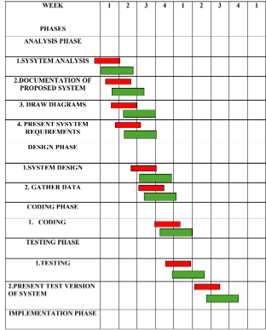

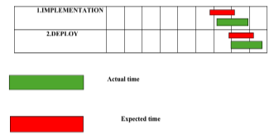

**CHAPTER 4**

**SYSTEM DESIGN**

### **4.1 METHODOLOGY**

The system follows the steps below to achieve its functionality:

#### **1. Data Collection**

* Collect multilingual datasets in Hindi, Marathi, and English for voice recognition and natural language processing.
* Gather text samples for camera-based text scanning and conversion to speech.
* Collect domain-specific data for Math, Biology, Chemistry, and Physics modules to ensure accurate responses.

#### **2. Data Preprocessing Module**

* Perform noise removal and standardization on audio datasets.
* Normalize and annotate multilingual text data for speech-to-text and text-to-speech processing.
* Preprocess text images using OCR (Optical Character Recognition) tools for clean text extraction.

#### **3. Model Training**

* Train speech recognition models to handle Hindi, Marathi, and English with user-specific accents.
* Train domain-specific models for Math operations and subject-related queries (Biology, Chemistry, and Physics).
* Fine-tune pre-trained models for OCR and text-to-speech functionalities.

#### **4. Model Selection**

* Select the best-performing speech recognition and NLP models based on accuracy, response time, and multilingual handling.
* Choose lightweight models for deployment to ensure real-time performance.

#### **5. Model Evaluation**

* Test speech recognition accuracy with different accents and noise levels in all three languages.
* Evaluate the correctness of responses in subject-specific modules (Math, Biology, Chemistry, Physics).
* Verify the OCR and text-to-speech output for text scanning functionality.

#### **6. User Interface Development**

* Design a user-friendly interface to input voice queries and display results in the user’s preferred language.
* Integrate real-time camera functionality for text scanning and output audio playback.
* Provide modular options for accessing Math, Biology, Chemistry, and Physics functionalities.

This methodology ensures seamless integration of multilingual capabilities, educational modules, and real-time text-to-speech functionalities for learners.

**4.2 SYSTEM ARCHITECTURE**

#### **A. Existing Architecture**

#### In the existing architecture, the system only supports commands in English. The process involves the following steps:

* The user provides an input or command in English.
* The system converts the speech input into text format using Automatic Speech Recognition (ASR).
* Natural Language Processing (NLP) interprets the text and executes the corresponding action or task.
* The output is delivered to the user in audio format using Text-to-Speech (TTS) technology.

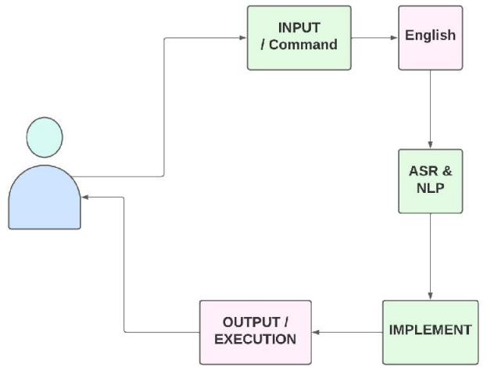

#### **B. Proposed Architecture**

In the proposed architecture for a real-time multilingual virtual voice assistant, the system supports commands in multiple languages, including Hindi, Marathi, and English. The process involves the following steps:

* The user provides an input or command in their preferred language (Hindi, Marathi, or English).
* The system captures the audio input and converts it into text format using Automated Speech Recognition (ASR) technology.
* The text is processed using Natural Language Processing (NLP) to understand the user’s query and determine the appropriate response.
* For subject-specific queries, such as Math, Biology, Chemistry, or Physics, the system accesses the respective module to generate accurate results.
* For educational purposes, the system also allows scanning text from the camera, processes it using Optical Character Recognition (OCR), and converts it to speech output.
* The desired output is provided to the user in their preferred language using Text-to-Speech (TTS) technology.

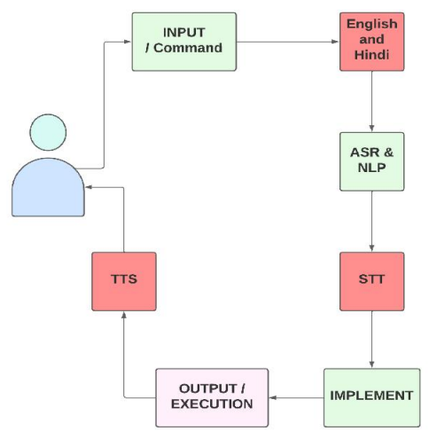

This proposed architecture enhances the user experience by supporting multilingual inputs, adding educational functionalities, and ensuring seamless interaction for learners in rural and multilingual regions.

**4.3 DATA FLOW DIAGRAM**

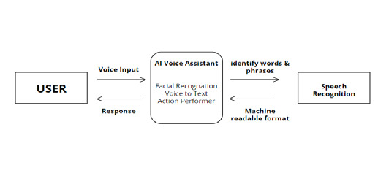

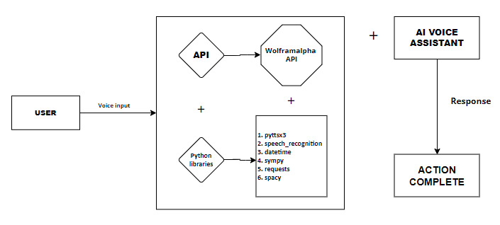**4.4 UML DIAGRAM**

The steps, starting from **user registration** to the final generation of a response or output, can be easily represented using a **use case diagram**, where **actors** are used to represent users and the system. Users register using certain parameters and then log in to their accounts to interact with the virtual voice assistant. They can submit queries in Hindi, Marathi, or English, or provide inputs such as scanned text, math problems, or subject-related questions. The system processes the inputs, stores necessary data in the database, and retrieves it as needed. For instance, it matches user queries with relevant data or modules (e.g., Math, Biology, Chemistry, or Physics), processes the query, and generates the appropriate response in the user's preferred language.

**4.5 ACTIVITY DIAGRAM**

In our **Real-Time Multilingual Virtual Voice Assistant for Learners** project, the Activity Diagram serves as a visual representation of the dynamic aspects of the system, illustrating the flow of activities or processes involved in handling user queries and generating responses. It focuses on the sequence of actions, decision points, and control flows within the system.

* **Wake Up**: Represents initializing the assistant in response to a trigger.
* **Wait for any incoming query**: Reflects the assistant's readiness to handle multilingual user queries (Math, Biology, etc.).
* **Decision Point**: Can align with processing user queries:

Commands might involve text-to-speech activation or camera text scanning.

Questions could relate to subject-specific queries or general knowledge.

Quit action would terminate the session.

* **Execute Command/Query**: Covers response generation in the user's preferred language or executing specific tasks.

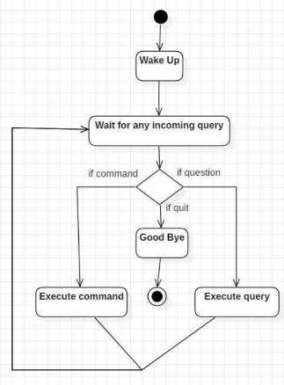

**4.6 PROPOSED INPUT AND OUTPUT DESIGN**

**Input Design:**

In the context of our real-time multilingual virtual voice assistant for learners, input design is key to enabling a seamless interaction between the user and the system. The system processes user queries in multiple languages (Hindi, Marathi, and English) and provides responses in their preferred language. The input design focuses on how the users communicate with the system, either by speaking questions or requests. It involves crafting a system that allows smooth voice recognition, ensuring that the assistant can understand user queries in the specified languages, and process them accurately for appropriate responses.

The effectiveness of the system's language processing, including text scanning and voice recognition, is heavily reliant on well-designed input mechanisms. This includes handling voice commands, detecting language preferences, and extracting meaningful information from spoken queries. A robust input system ensures that the assistant responds efficiently, no matter the complexity of the question or language used.

**Objectives for Input Design:**

1. **Multilingual Support:** Ensure that the system can accurately understand and process user input in Hindi, Marathi, and English.
2. **User-Friendliness:** Design intuitive voice interfaces that allow users to easily interact with the assistant for queries related to subjects like Math, Biology, Chemistry, and Physics.
3. **Accuracy:** Enable precise voice recognition and processing to enhance response quality and relevance.
4. **Efficiency:** Optimize voice recognition to minimize delays, enabling quick and effective responses.
5. **Inclusivity:** Provide flexible input mechanisms, such as speech and text scanning, to cater to a variety of users and learning preferences.
6. **Contextual Understanding:** Design input handling to ensure that the assistant accurately processes subject-specific queries and responds accordingly.

**Output Design:**

Output design focuses on how the virtual voice assistant responds to the user's queries in a clear, concise, and accurate manner. The system must provide responses not only in the language preferred by the user (Hindi, Marathi, or English) but also in a way that is easily understood. For instance, in subjects like Math, Biology, Chemistry, and Physics, outputs need to be detailed and precise, ensuring that the information is both relevant and actionable.

The system should be able to display or read aloud the response based on the query type. For instance, while answering math-related questions, it might present numerical results or step-by-step explanations. Similarly, for biology or chemistry queries, it would provide definitions, formulas, or explanations in a user-friendly manner. The design ensures that output is clear, relevant, and inspires user confidence in the system's accuracy and reliability.

**Objectives for Output Design:**

1. **Multilingual Response:** Ensure that the system responds in the user’s preferred language (Hindi, Marathi, or English) for all queries.
2. **Clarity and Understandability:** Design outputs that are easy to understand, ensuring that the information provided is clear, especially for academic subjects.
3. **Relevance and Actionability:** Ensure that the responses are directly relevant to the user’s query, and provide actionable insights, like formulas, definitions, or explanations.
4. **User Confidence:** Build user trust by ensuring accurate and reliable responses, fostering confidence in the system’s capabilities.
5. **Adaptability:** Design the output to be adaptable based on the user's background knowledge and language preference, making it accessible for learners of varying expertise levels.
6. **Text-to-Speech Integration:** For text-based results, the system should incorporate text-to-speech functionality to read aloud the results for users who prefer auditory learning.

This input and output design framework aims to facilitate seamless interaction with the voice assistant, ensuring a user-friendly and efficient experience while meeting the diverse needs of learners in various subjects.

**CHAPTER 5**

**IMPLEMENTATION AND TESTING**

**5.1 IMPLEMENTATION APROACHES**

The term implementation has different meanings ranging from the conversation of a basic application to a complete replacement of a computer system. The procedures however, are virtually the same. Implementation includes all those activities that take place to convert from old system to new. The new system may be totally new replacing an existing manual or automated system or it may be major modification to an existing system. The method of implementation and time scale to be adopted is found out initially. Proper implementation is essential to provide a reliable system to meet organization requirement.

**5.2 CODING**

**App.py**

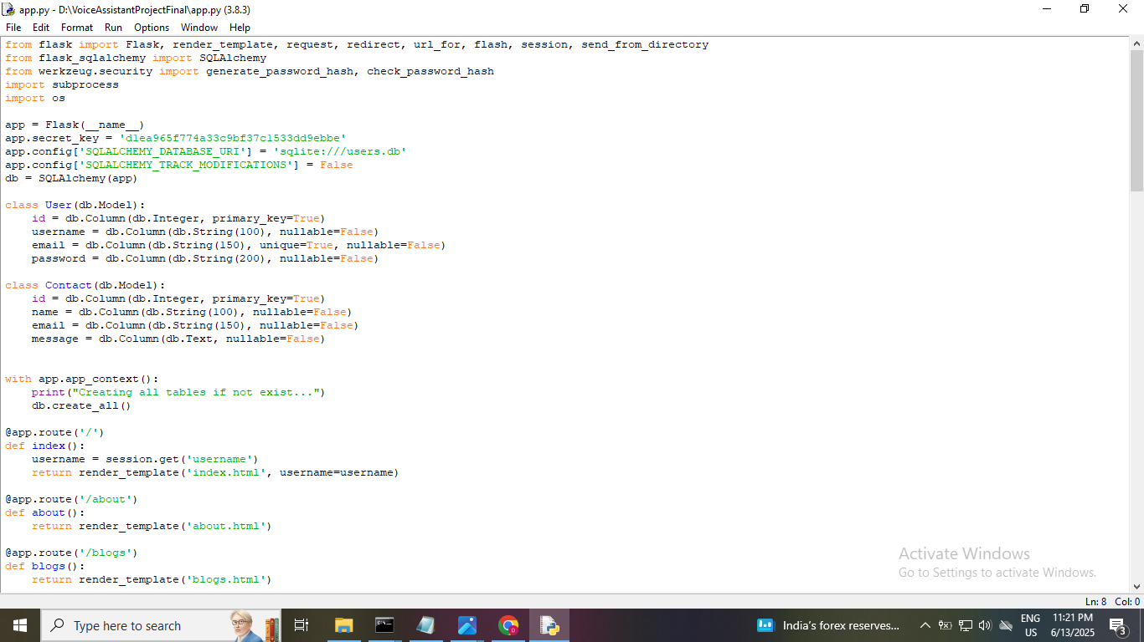

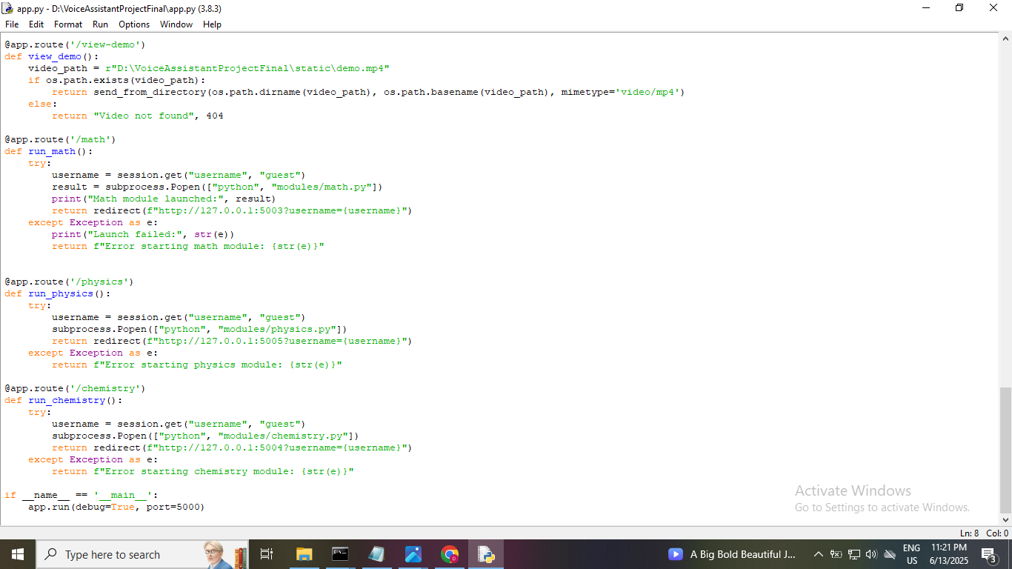**Biology.py**

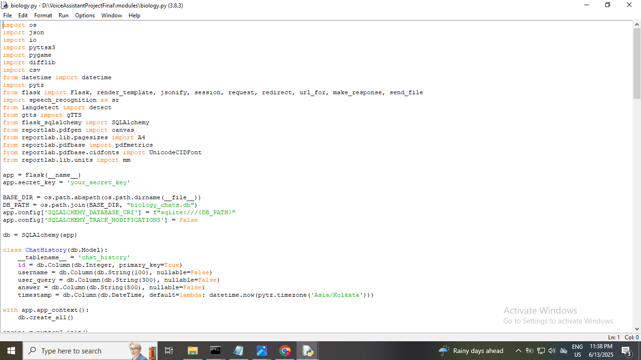

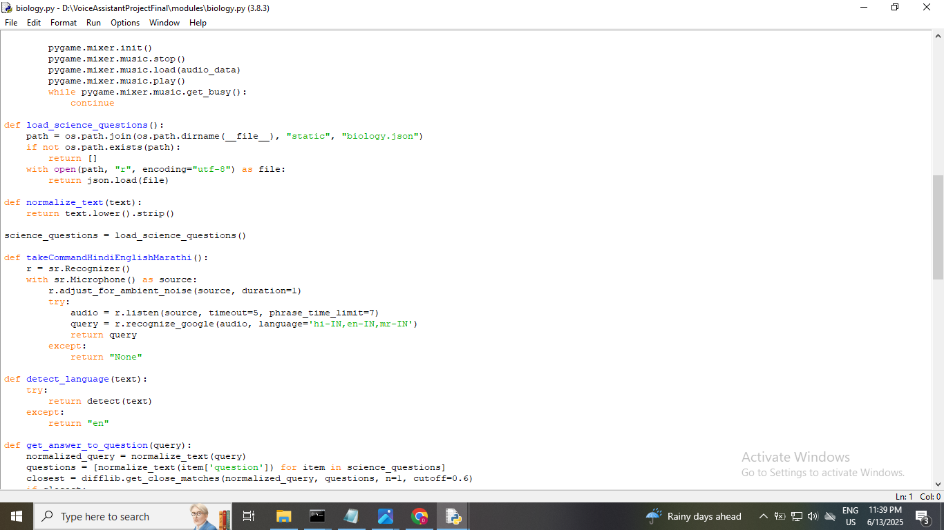

**Math.py**

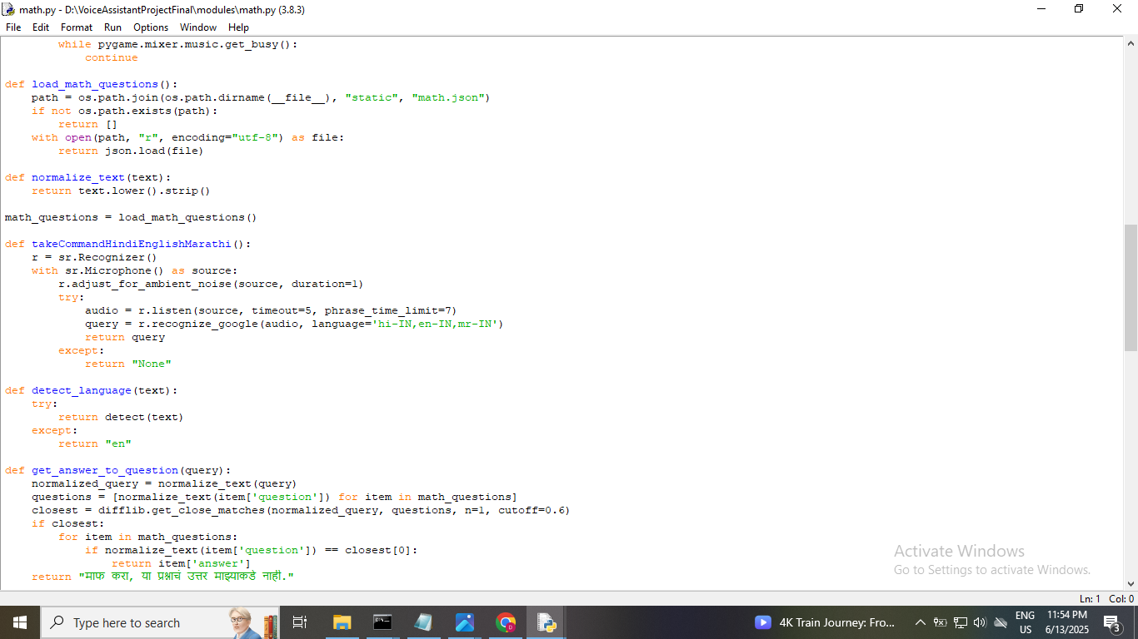

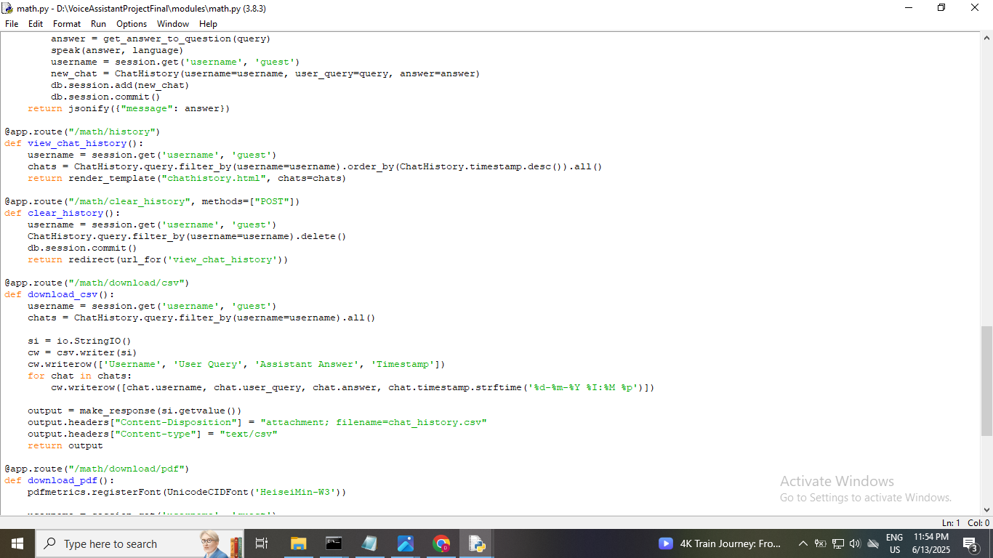

**Chemistry.py**

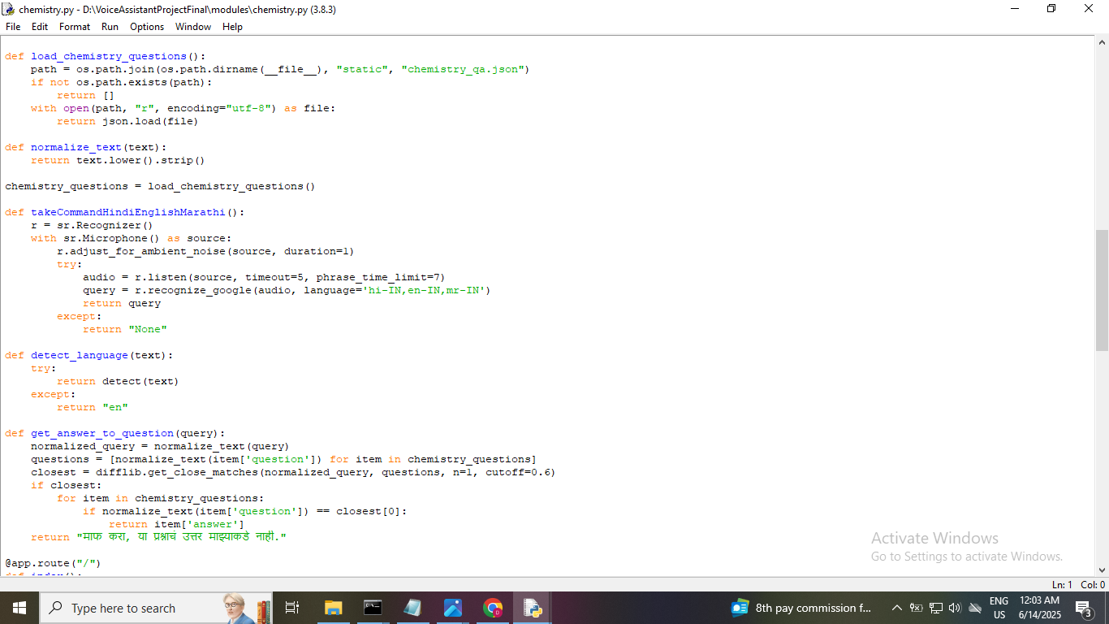

**Physics.py**

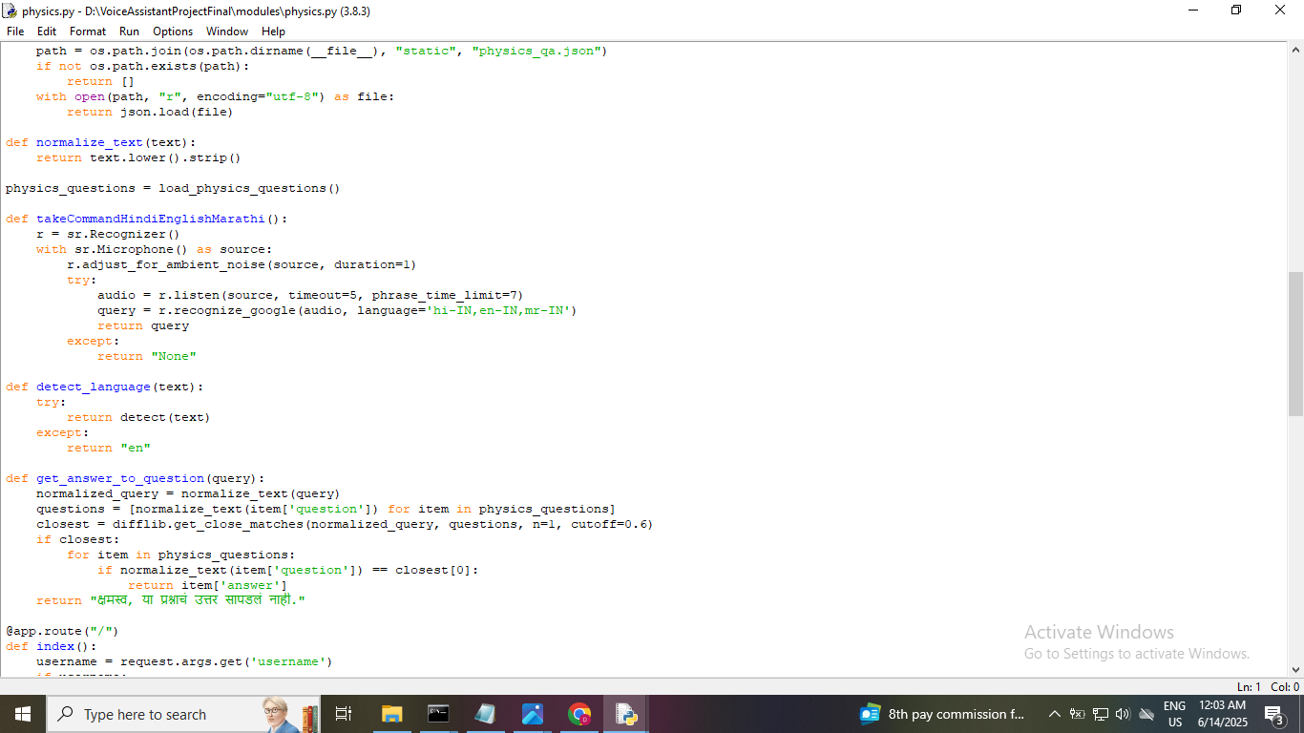

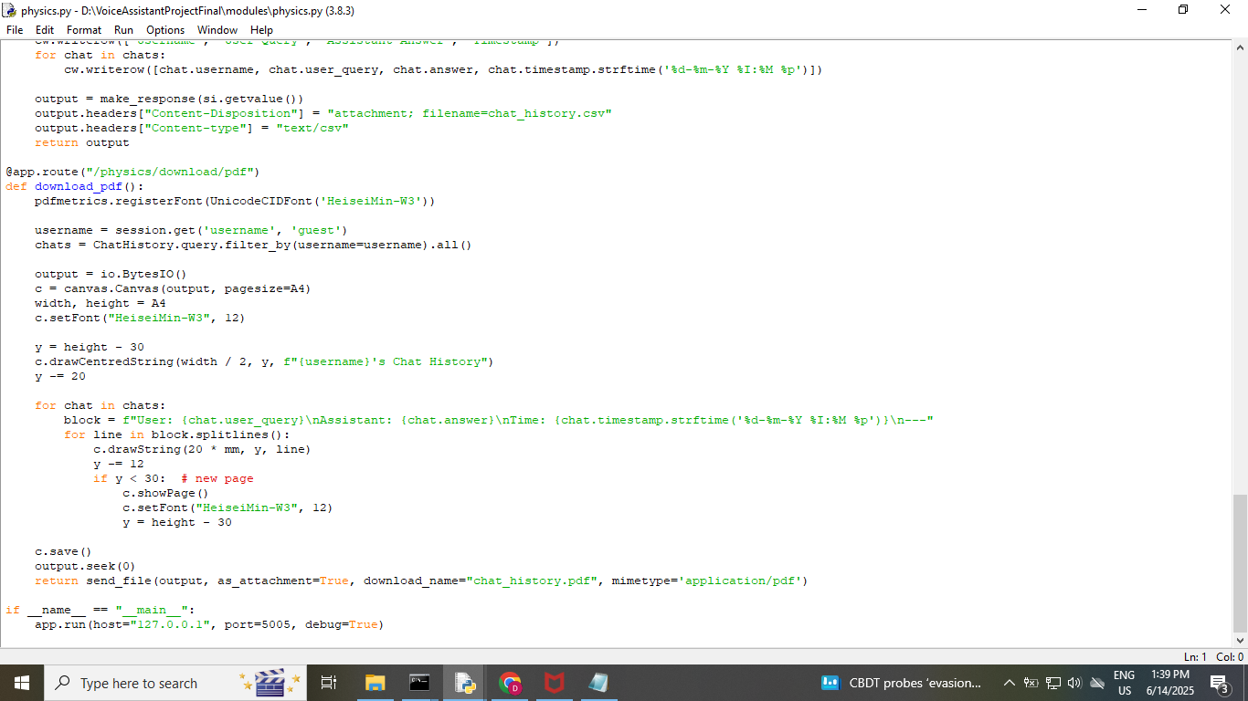

**5.3 Testing**

System testing of software or hardware is testing conducted on a complete, integrated system to evaluate the system's compliance with its specified requirements. System testing falls within the scope of black-box testing, and as such, should require no knowledge of the inner design of the code or logic. As a rule, system testing takes, as its input, all of the "integrated" software components that have passed integration testing and also the software system itself integrated with any applicable hardware systems. The purpose of integration testing is to detect any inconsistencies between the software units that are integrated together (called assemblages) or between any of the assemblages and the hardware. System testing is a more limited type of testing; it seeks to detect defects both within the "inter-assemblages" and also within the system as a whole.

System testing is performed on the entire system in the context of a Functional Requirement Specifications (FRS) and/or a System Requirement Specification (SRS). System testing tests not only the design, but also the behavior and even the believed expectations of the customer.

It is also intended to test up to and beyond the bounds defined in the software/hardware requirements specifications.

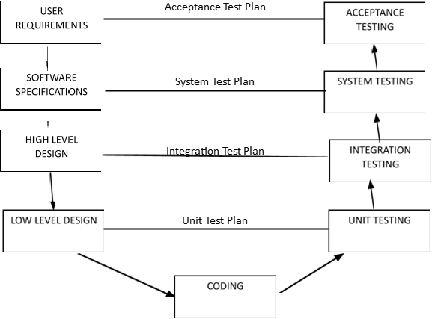

**5.4 Test Case Design**

Test case design refers to how you set-up your test cases. It is important that your tests are designed well, or you could fail to identify bugs and defects in your software during testing. There are many different test case design techniques used to test the functionality and various features of your software.

|  |  |  |  |  |
| --- | --- | --- | --- | --- |
| **Test Case** | **Test Case Description** | **Expected Results** | **Pass/ Fail** | **Actual Results** |
| **1.** | Biology - English Query- What is photosynthesis? | Photosynthesis is the process by which green plants and some other organisms use sunlight to synthesize foods from carbon dioxide and water. | Pass | Assistant recognizes the English query, gives correct response, and speaks it. |
| **2.** | Biology - Hindi Query- फोटोसिंथेसिस क्या है? | फोटोसिंथेसिस वह प्रक्रिया है जिसके द्वारा हरे पौधे और कुछ अन्य जीव सूर्य के प्रकाश का उपयोग करके कार्बन डाइऑक्साइड और जल से खाद्य पदार्थ संश्लेषित करते हैं। | Pass | Assistant recognizes the Hindi query, gives correct response, and speaks it. |
| **3.** | Biology - Marathi Query-  फोटोसिंथेसिस म्हणजे काय? | फोटोसिंथेसिस ही अशी प्रक्रिया आहे ज्याद्वारे हिरव्या वनस्पती आणि काही इतर जीव कार्बन डायऑक्साइड आणि पाण्यापासून अन्न संश्लेषित करण्यासाठी सूर्यप्रकाशाचा वापर करतात. | Pass | Assistant recognizes the Marathi query, gives correct response, and speaks it. |
| **4.** | Math - English Query- what is derivative | A derivative represents the rate of change of a function with respect to a variable. | Pass | Assistant recognizes the English query, gives correct response, and speaks it. |
| **5.** | Math - Hindi Query- १६ का वर्गमूल क्या है | १६ का वर्गमूल ४ होता है। | Pass | Assistant recognizes the Hindi query, gives correct response, and speaks it. |
| **6.** | Math - Marathi Query- ५ चा घन काय आहे | ५ चा घन १२५ आहे. | Pass | Assistant recognizes the Marathi query, speaks it. |
| **7.** | Chemistry - English Query- Who discovered oxygen? | Oxygen was discovered by Joseph Priestley in 1774. | Pass | Assistant recognizes the English query, gives correct response, and speaks it. |
| **8.** | Chemistry - Hindi Query- हाइड्रोक्लोरिक एसिड का सूत्र क्या है | हाइड्रोक्लोरिक एसिड का रासायनिक सूत्र HCl है। | Pass | Assistant recognizes the Hindi query, gives correct response, and speaks it. |
| **9.** | Chemistry - Marathi Query- हेलियमचा अणुभार किती आहे | हेलियमचा अणुभार सुमारे ४ आहे. | Pass | Assistant recognizes the Marathi query, speaks it. |
| **10.** | Physics - English Query- Why do objects fall to the ground? | Due to Earth's gravitational pull. | Pass | Assistant recognizes the English query, gives correct response, and speaks it. |
| **11.** | Physics - Hindi Query- गति और वेग में क्या अंतर है? | गति अदिश है जबकि वेग सदिश है। | Pass | Assistant recognizes the Hindi query, gives correct response, and speaks it. |
| **12.** | Physics - Marathi Query- वेग आणि गतीत काय फरक आहे? े | गती ही अदिश आहे आणि वेग हा सदिश आहे. | Pass | Assistant recognizes the Marathi query, speaks it. |

**CHAPTER 6**

**RESULTS & DISCUSSIONS**

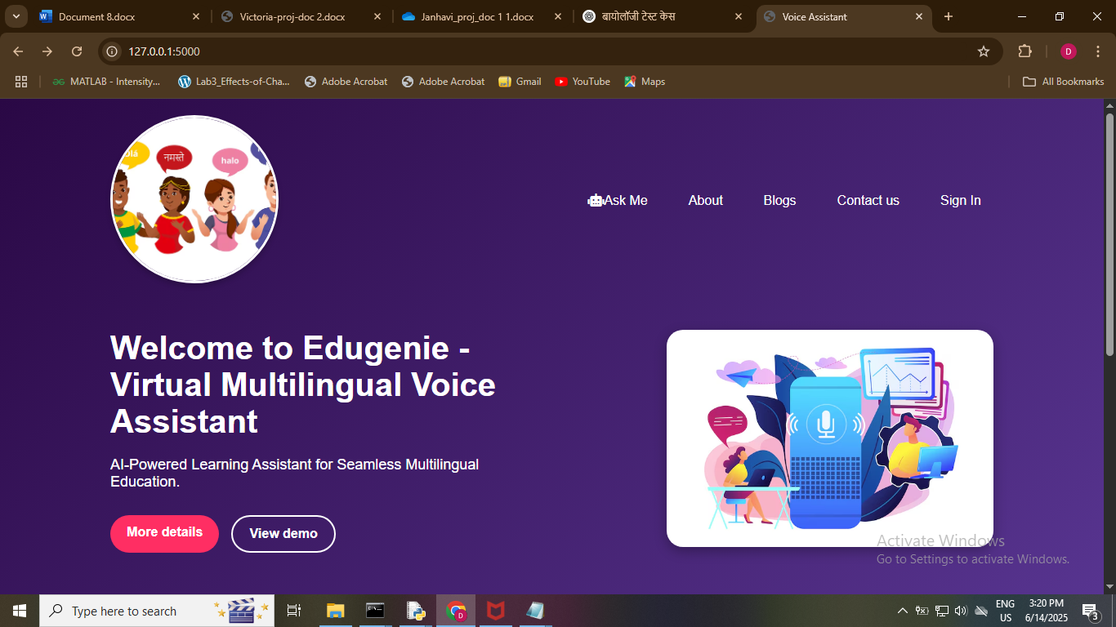

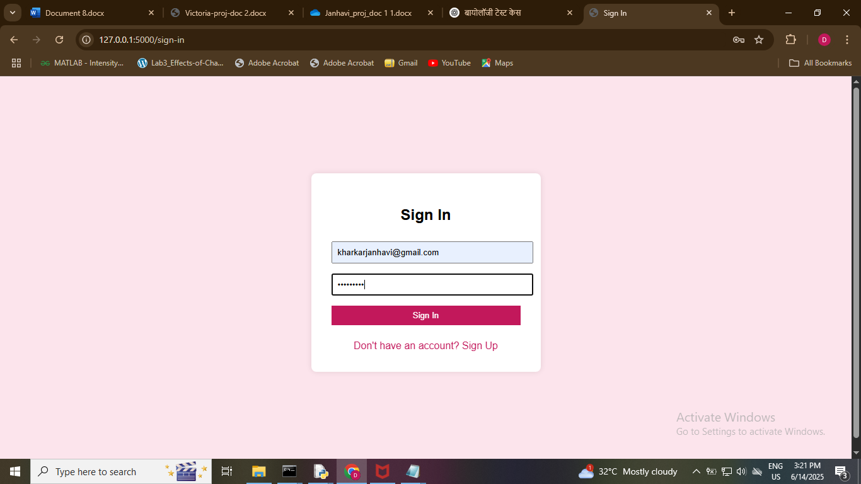

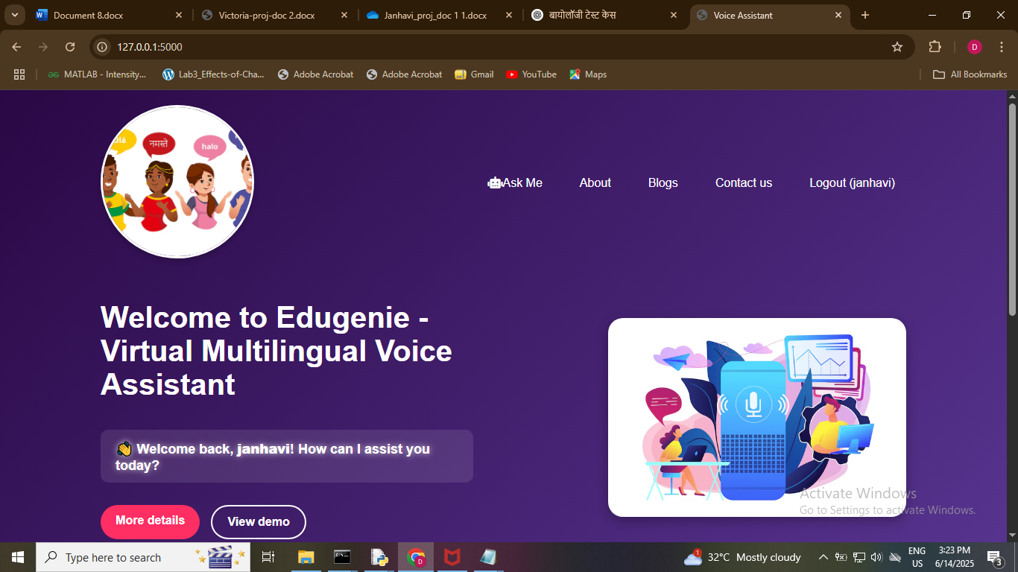

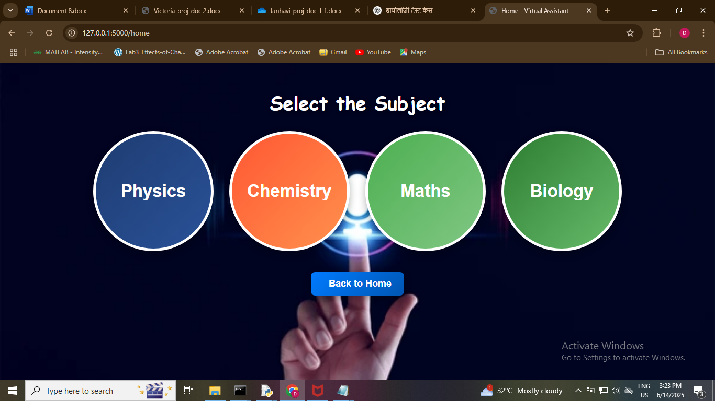

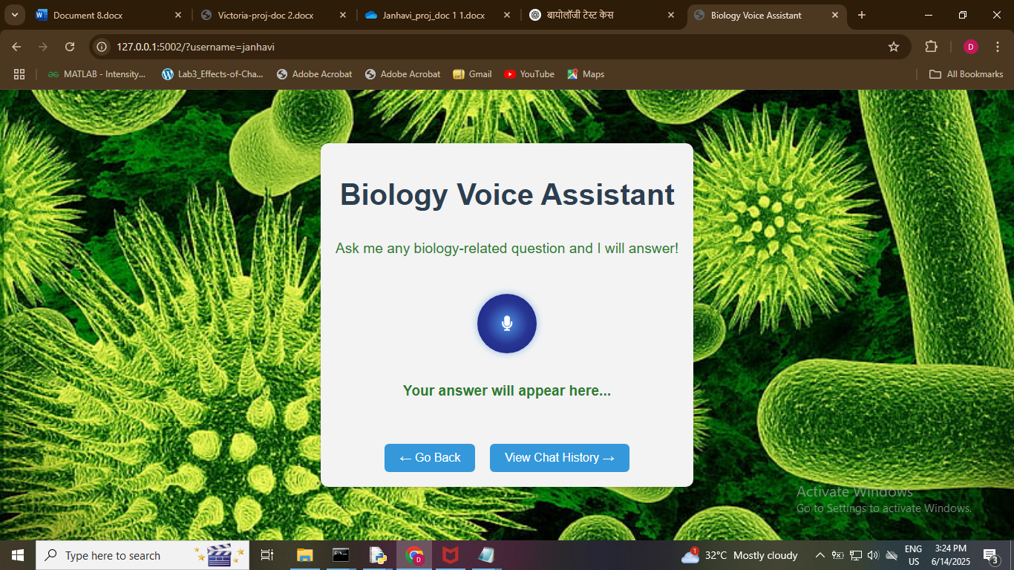

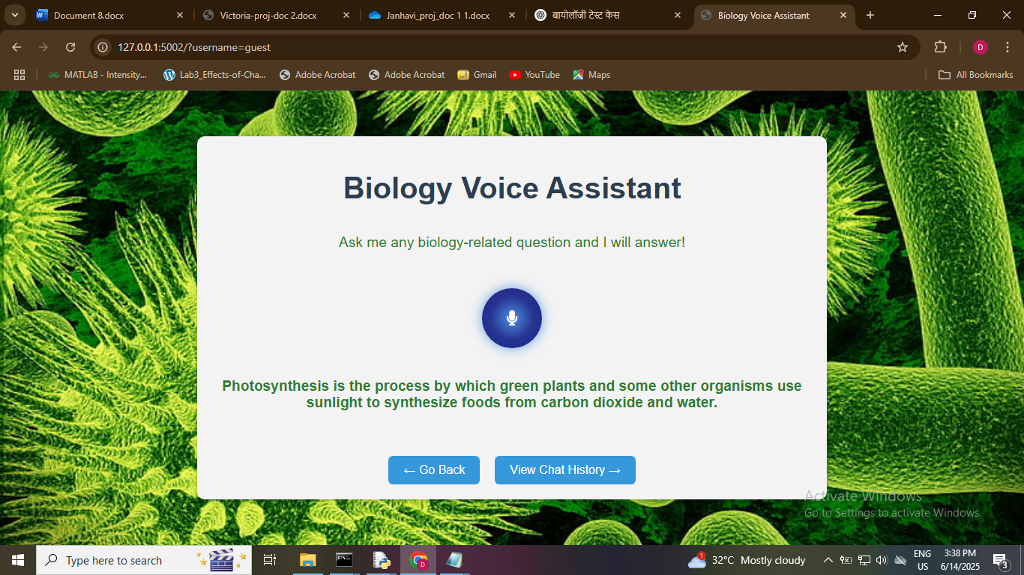

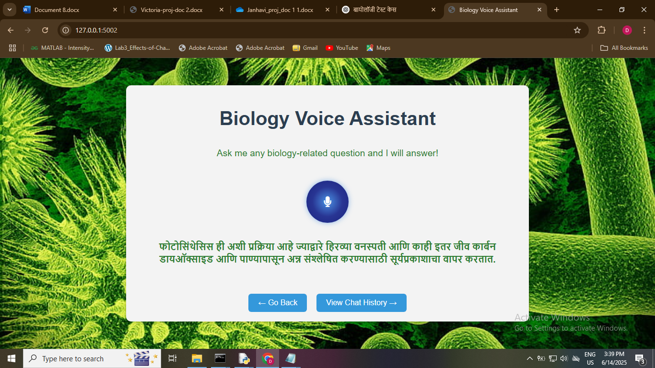

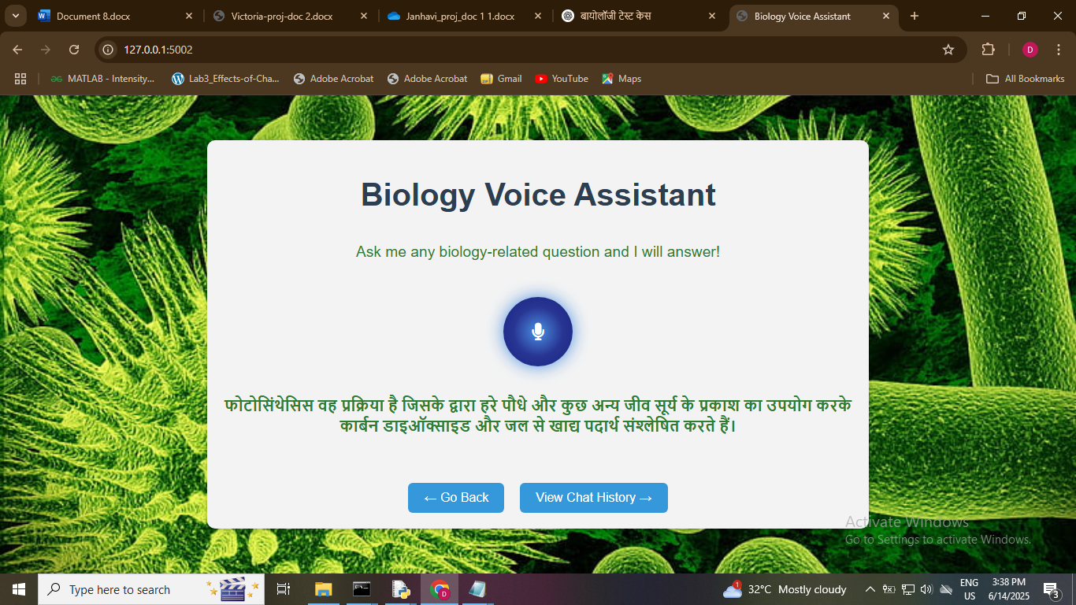

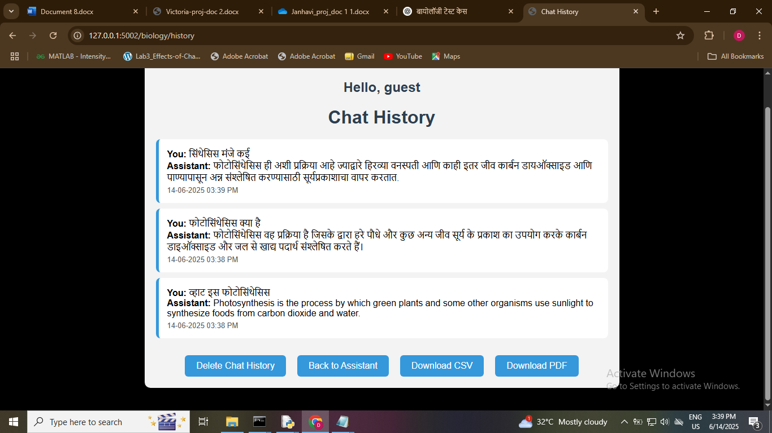

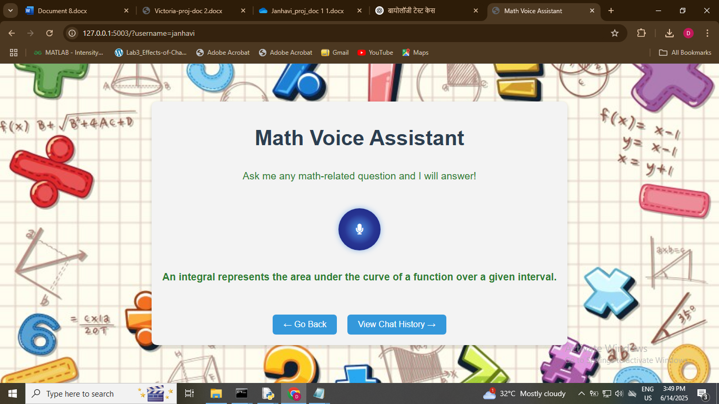

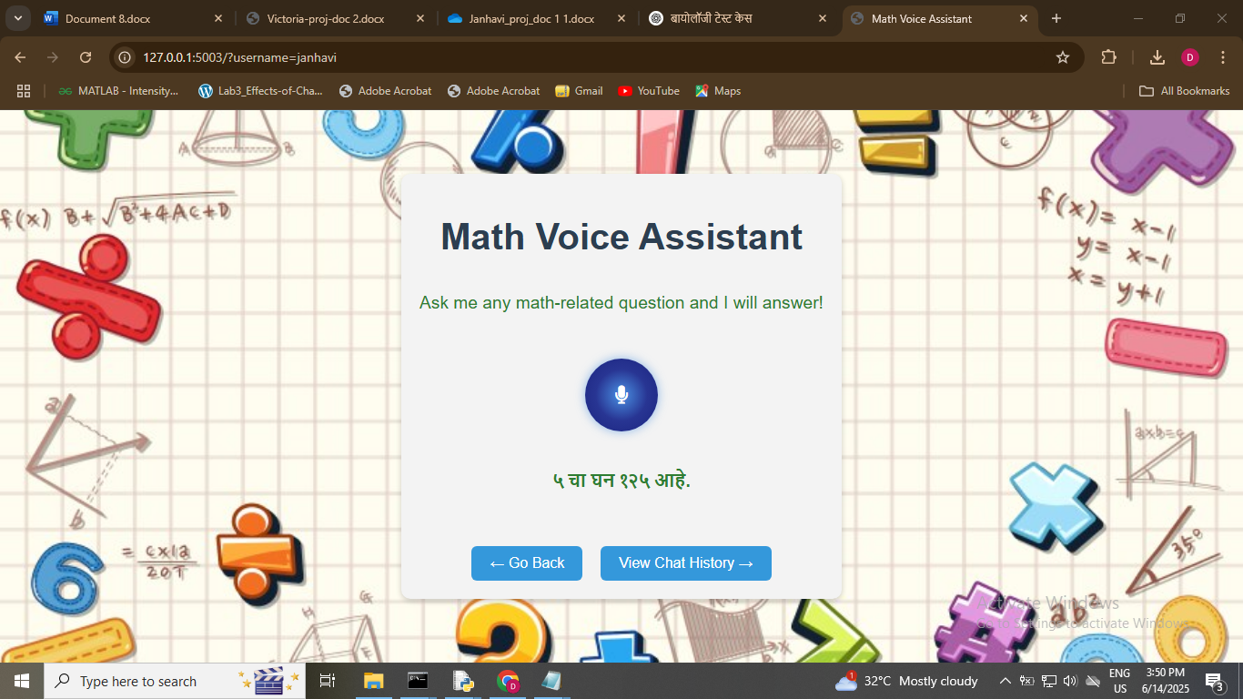

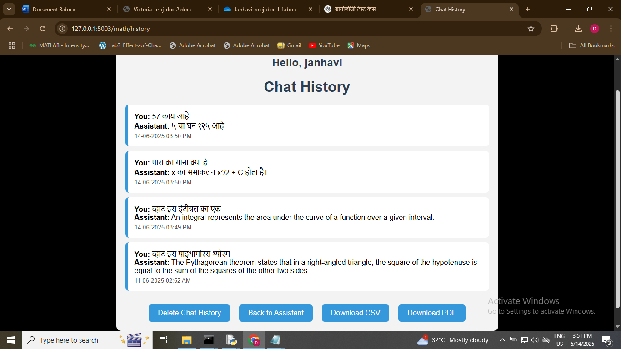

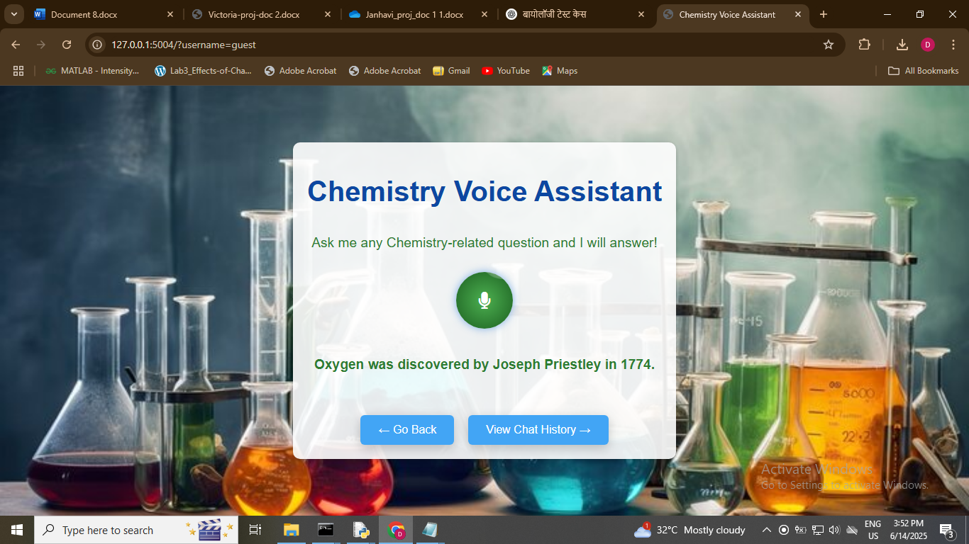

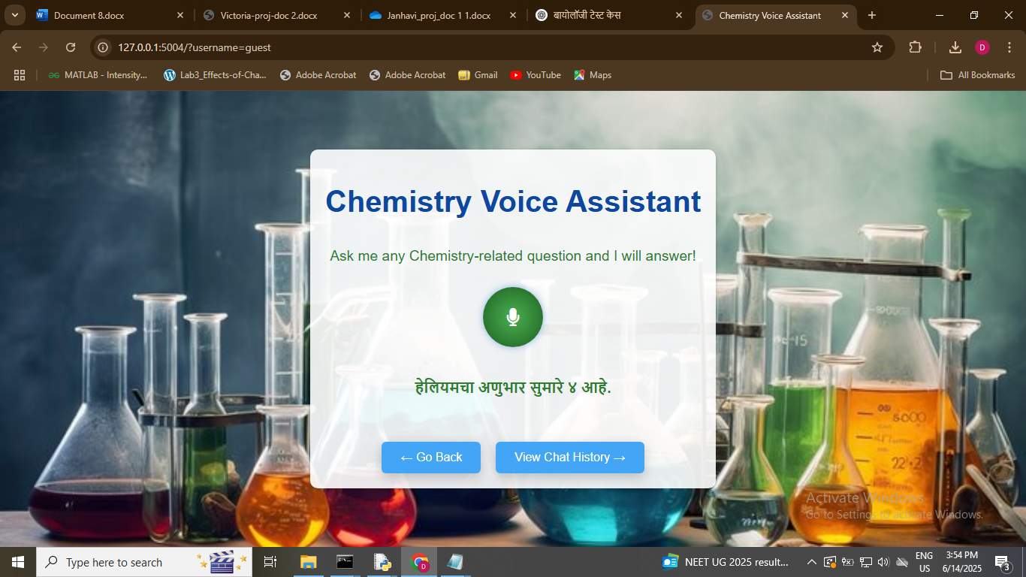

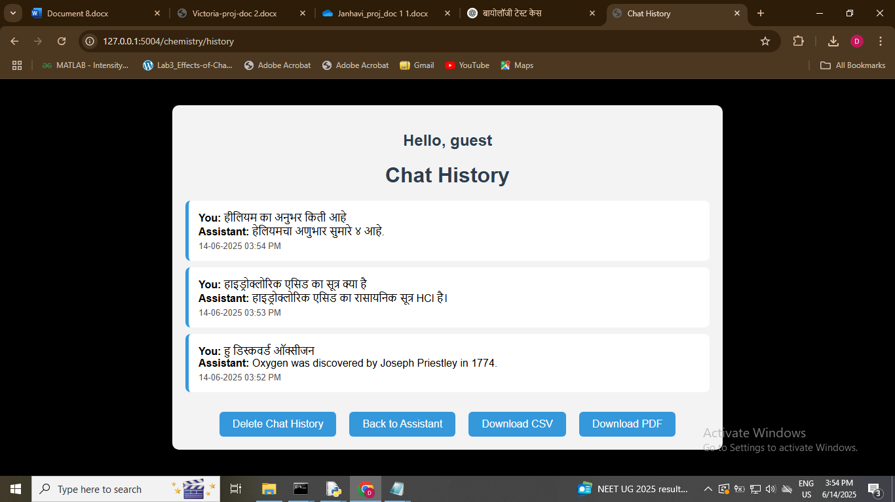

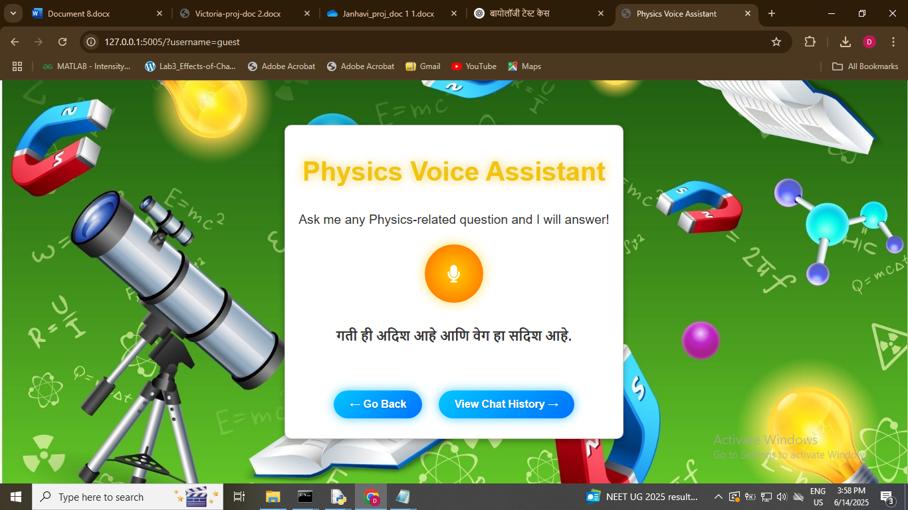

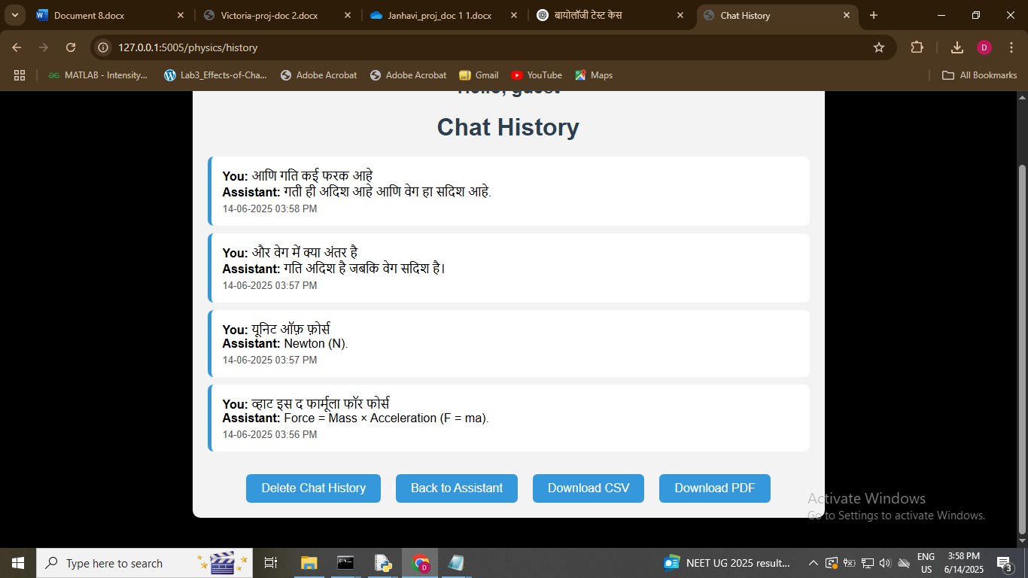

**CHAPTER 7**

**CONCLUSION**

In conclusion, our project presents a real-time multilingual virtual voice assistant specifically designed for learners, incorporating four essential academic domains: Math, Chemistry, Physics, and Biology. The system enables users to interact naturally using voice-based queries in three languages—English, Hindi, and Marathi—bridging language barriers in education and supporting diverse linguistic communities. This multilingual capability ensures that learners can engage with the assistant in their preferred language, fostering inclusivity and better understanding of complex concepts.

To ensure seamless user interaction, the assistant leverages a robust combination of technologies. The backend is powered by **Flask**, providing a lightweight and scalable web framework, while **SpeechRecognition** handles voice input. For audio output, **gTTS** and **pyttsx3** convert responses into natural-sounding speech, and **Googletrans** is used for automatic language translation. For mathematical processing, the assistant utilizes **SymPy**, and all user interactions are logged using **SQLite** for easy retrieval of chat history. Most notably, the assistant integrates **GPT4All**, an open-source large language model, to generate accurate, intelligent, and context-aware answers when predefined responses are not available—making the system far more dynamic and responsive to varied queries.

To validate its performance, we developed a comprehensive set of **12 test cases**, with three test cases assigned to each academic module. Each module was evaluated using queries in English, Hindi, and Marathi, ensuring the assistant’s multilingual capabilities were thoroughly tested. The system consistently demonstrated accurate language detection, effective query interpretation, contextually appropriate responses, and high-quality voice output across all tests. This successful testing confirms the system’s reliability and usability in real-world educational scenarios.

Overall, this multilingual voice assistant showcases the powerful intersection of speech technology, natural language processing, and AI-driven knowledge systems in education. By enabling real-time, interactive, and language-inclusive learning, it opens the door to personalized and accessible education for a wider audience. Future enhancements may include expanding subject coverage, integrating more regional languages, improving natural dialogue through advanced large language models, and deploying the system on mobile devices or Raspberry Pi for broader reach. With these developments, the assistant has the potential to become a valuable tool for students, educators, and self-learners alike, revolutionizing how knowledge is accessed and delivered in multilingual environments.

**CHAPTER 8**

**REFERENCES**

**References**

1. Brown, T., Mann, B., Ryder, N., Subbiah, M., Kaplan, J., Dhariwal, P., ... & Amodei, D. (2020). Language models are few-shot learners. Advances in Neural Information Processing Systems, 33, 1877–1901. <https://arxiv.org/abs/2005.14165>
2. Kudo, T., & Richardson, J. (2018). SentencePiece: A simple and language-independent subword tokenizer and detokenizer for neural text processing. Proceedings of the 2018 Conference on Empirical Methods in Natural Language Processing: System Demonstrations, 66–71. https://arxiv.org/abs/1808.06226
3. Pan, Y., Wang, X., Zhang, C., & Zheng, Y. (2020). An intelligent voice assistant system based on speech recognition and natural language understanding. IEEE Access, 8, 99427–99437. https://doi.org/10.1109/ACCESS.2020.2997205
4. Purohit, H., Hampton, A., Laugé, A., & Muthukumar, V. (2021). Multilingual voice interface for inclusive education in low-resource environments. International Journal of Educational Technology in Higher Education, 18(1), 1–16. https://doi.org/10.1186/s41239-021-00254-4
5. OpenAI. (2023). GPT-4 Technical Report. https://openai.com/research/gpt-4
6. Tuck, N. (2023). Building AI Chatbots with GPT4All: The Complete Guide. Packt Publishing.
7. Google Cloud. (n.d.). Speech-to-Text API Documentation. https://cloud.google.com/speech-to-text/docs
8. SymPy Development Team. (2023). SymPy: Python library for symbolic mathematics. https://www.sympy.org/en/index.html
9. Google. (n.d.). Googletrans: Free and Unlimited Python API for Google Translate. https://py-googletrans.readthedocs.io/
10. Python Software Foundation. (2023). Flask: Web development, one drop at a time. https://flask.palletsprojects.com/

**Similarity Report by Project Guide**

|  |  |  |  |  |  |
| --- | --- | --- | --- | --- | --- |
| 1. | Name of the Candidate | Janhavi Vijay Kharkar | | | |
| 2. | University Examination Seat Number |  | | | |
| 3. | Project Title | A Real-Time Multilingual Virtual Voice Assistant for Learners | | | |
| 4. | Name of the Project Guide | Dr.Sunitha Joshi | | | |
| 5. | Similarity Percentage | Pct | % | % | % |
| Date |  |  |  |
| 6. | Name of the plagiarism detection tool used | Dupli Checker | | | |
| 7. | Submission Date |  | | | |
| 8. | Remarks |  | | | |

Checked by  
Project Guide / Coordinator: ____________________________  
Date: ____________________

**Final Similarity Check Report generated by plagiarism checker tool**

